Adding SampleR Number, SaMple ID, and Manifest to Piper SYstem
INDEX | SCREEN | ACTION
P1  Register trailer on Piper System View Ports | 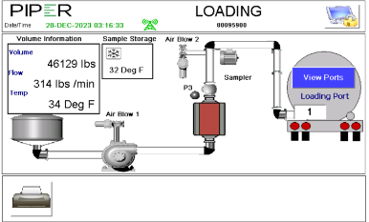 | Press the View Ports Button  Note: You can pre-register a trailer at any time. This can be done by the farm operative or driver depending on the farm operating procedures
P2  Select Port | 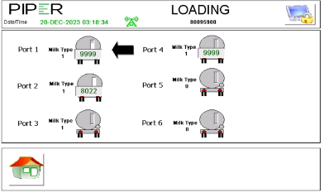 | Tap on the trailer icon to select the port number at which the trailer will be registered
P3  Enter Trailer Number | 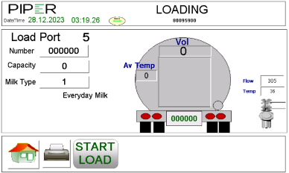  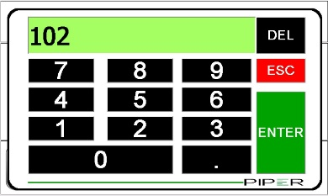 | To enter the trailer number tap on the box that contains the number 0000 or 9999 in the Number box  When the virtual keypad is displayed, enter the trailer number and press ENTER
M1  Perform Pick-up on Mobile Manifest app | 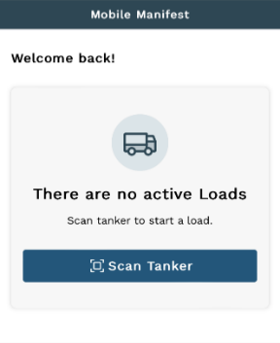 | Tap Scan Tanker.
M2  Scan tanker | 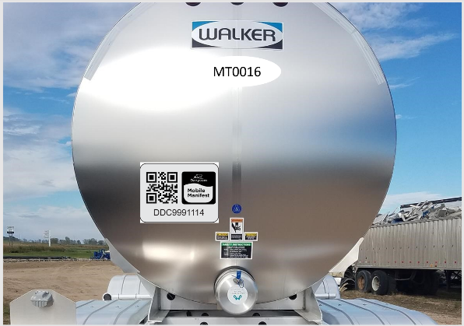 | Scan the tanker's barcode
M3  Enter seals | 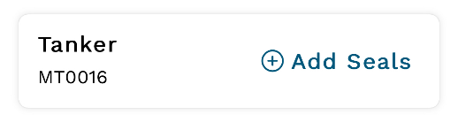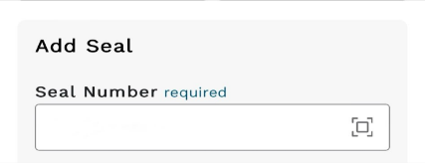  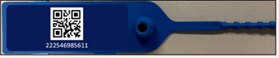  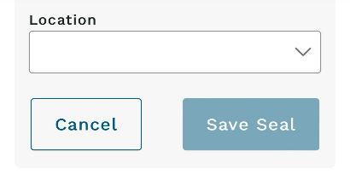 | Tap Add Seals to open the Seal ribbon.  Tap  to scan the Seal Number.  Scan the Seal number barcode.  Tap the drop-down arrow on the seal box location.  Select the seal's location and tap OK.  Tap Save Seal.
M4  Enter wash tag | 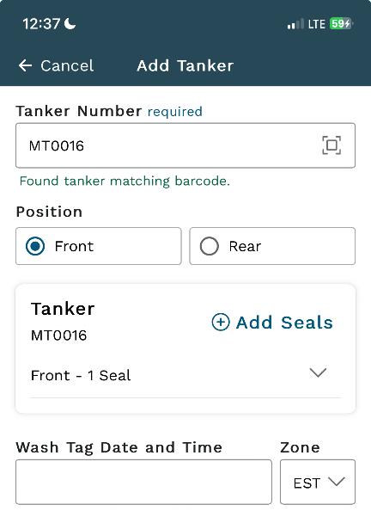  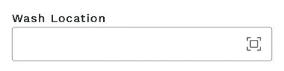 | Tap Wash Tag Date and Time and Select Date.  Tap Wash Location and enter location.
M5  Select hauler | 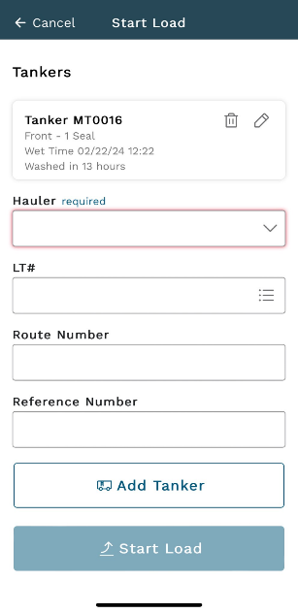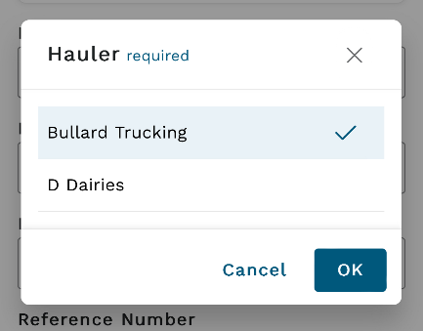 | Tap Hauler dropdown and select Hauler then tap OK
M6  Select LT | 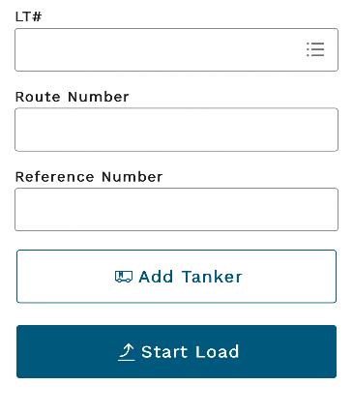  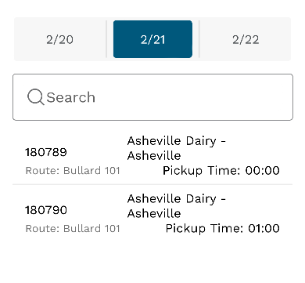 | Select then tap the LT# icon and select the LT#.
M7  Start producer pickup | 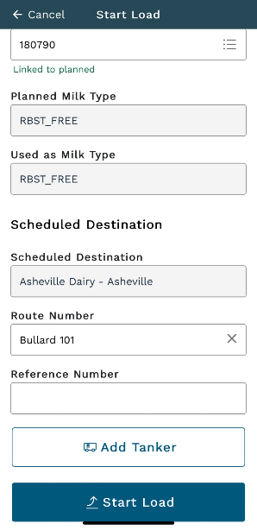 | Tap Start Load to save and return to the home screen.
M8 | 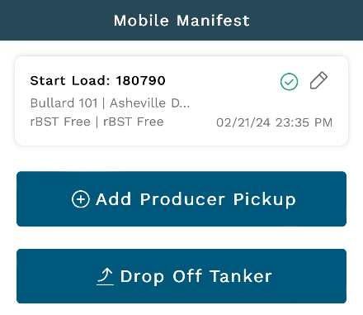 | Tap Add Producer Pickup.
M9  Select farm | 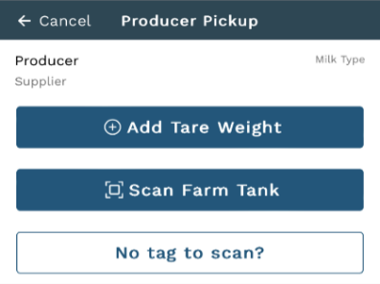  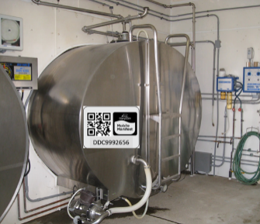 | Tap Scan Farm Tank.  Scan the Tank Number barcode.
M10  Add temperature | 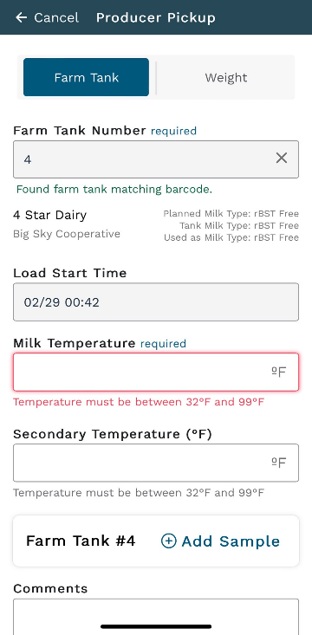 | Enter the Milk Temperature (°F).  Tap Add Sample.
M11  Add sample information | 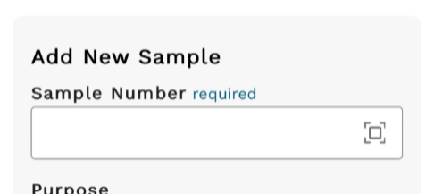  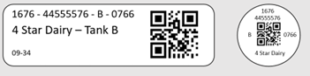  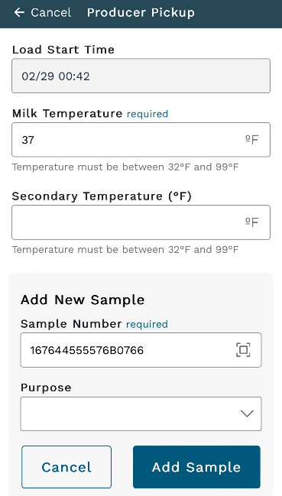 | Tap to scan Sample Number barcode.  Scan Sample Number barcode.  Tap the drop-down arrow on the sample Purpose box.  Select the Purpose. Tap OK.  Select Add Sample to save sample.  Enter Comments if desired.  Tap Next.
M12  Enter weight | 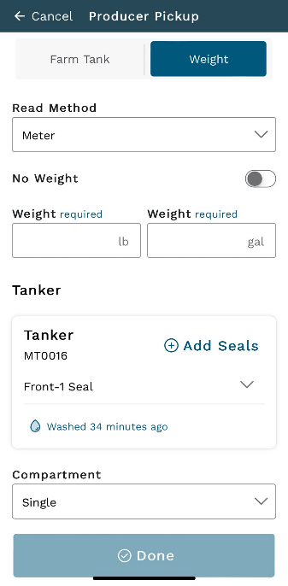  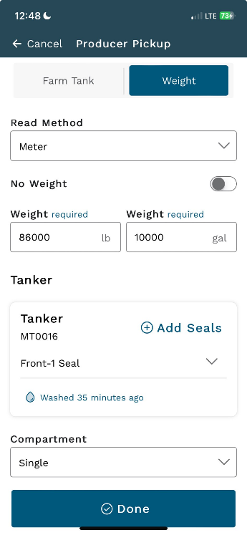 | Enter Weight  Tap Done.
M13  Complete pickup | 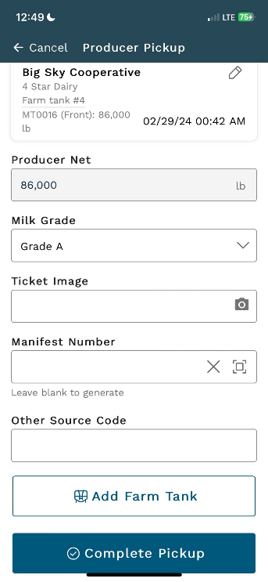 | Tap Complete Pickup.  Note: follow deliver load instructions next at plant
M14  Find Manifest # | 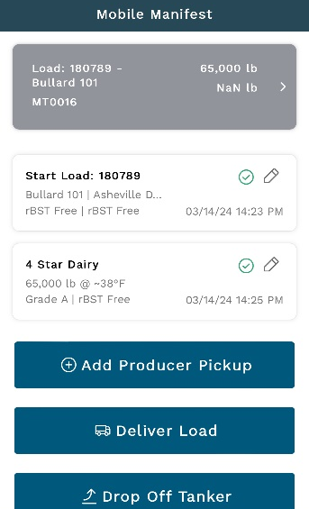  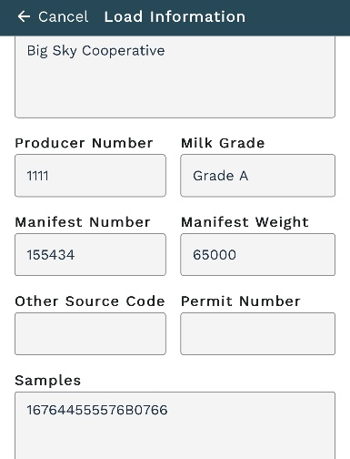 | Tap the grey load information at top  Scroll down to get the Manifest Number
P4  Switch to Piper system  End Load |  | Press the View Ports button  Press on the trailer icon to select the port number at which the trailer will be un-registered
P5  Finish The Load | 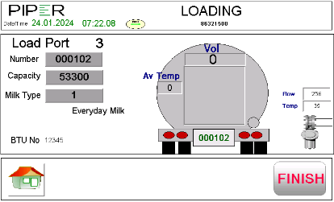 | Press the FINISH button  Note: This process can be carried out at any time after the trailer is full and before the trailer is picked up by the driver
P6  Enter / Scan The Load Details | 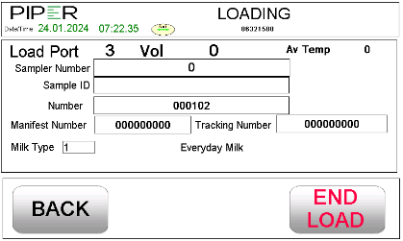 | - Sampler Number (Sampler License Number)  - Sample ID (Sample Vial QR Code)  - Manifest and or Tracking Number(s)  Press END LOAD to print the ticket and un-register the trailer form the port

